 COSC 2320
Name: _________________ Terminal #__

Estimated Hours 1
Actual Hours

TA (Textual Analysis) for UML MVC CLASS Diagram MODEL
Programming Assignment 3:
(10 points)
(Due date found in the COSC 2320 BB Calendar!)
You must use Microsoft WORD program. Insert the TEMPLATEs for Class, Attribute, and Method in this Requirements Document.

Please have Step 1, 2, 3, 4, and 5 in this order.
Requirements Analysis: Construct the UML MVC Class Diagram MODEL

Hash Table - Chaining - Cell Phone Contact List Application
ProgrammingAssignment3 APPLICATION
A cell phone manufacturer would like a Java program (Using MVC classes, design an ProgrammingAssignment3 APPLICATION) that maintains the list of contacts for a cell phone owner. For each contact, a person’s name, there should be a list of phone numbers that can be changed. The manufacturer desires an interface for the software
ContactInterface ContactList
(ContactListInterface and ContactList Class).
View Cellphone Manufacturer Controller

AddOrChange
AddOrChange 1: Name AddorChange 2: phonenumber 1
- addOrChangeEntry( String name, List< String> numbers)
UC 1 : AddorChangeEntry
Changes the numbers associated with the given name or adds a new entry with this name and list of numbers. Returns the old list of numbers or null if this is a new entry.
Controller 2: lookUp
lookupEntry( String name) UC 1 :LookUp
Searches the contact list for the given name and returns its list of numbers or null
if the name is not found.
Controller 3: removeEntry
removeEntry( String name) UC 1 : RemoveEntry
Removes the entry with the specified name from the contact list and returns its list of numbers or null if the name is not in the contact list.
Controller 4:Display
display(); UC 1 : Display

Displays the contact list in order by name.

Hashtable
A hash table Class is an ideal data structure for the contact list. It will associate names (which are unique) to lists of phone numbers. Therefore, the name is a key field and the list of phone numbers “is” the value field.

Sample entries would be:

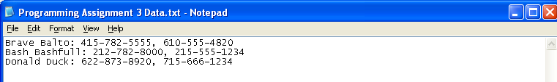

Create a ProgrammingAssignment3.java that contains the main method.

Main
callMenu();

Viewer
Menu();

ContactInterface
-userinput: int

ContactList
Controller
-STRLEN: int
-information[]:string[]
addOrChangeEntry()
lookupEntry()
removeEntry
display()
Node
AddNewEntry
-name: string
-phonenumber1: string
-phonenumber2:string
HashTable

Viewer
Public void display()
{
Display the String “Please Choose an option”
Display the String “1.Add or Change Entry”
Display the String “2. LookUp Entry”
Display the String “3. RemoveEntry”
Display the String “4. Display”
}

Controller
Public void UCAddorChangeEntry(String name, String <> phonenumber)
{
}
Public void UCLookupEntry(String name)
{
}

Public void UCRemoveEntry(String name)
{
}
Public void UCDisplay
{
}

